Structured Data Repository Service
This section provides more detailed information about the use of DiverSea Data Space structured data browsing service. It allows to explore the data in structured format, after its internal curation to meet the structuring, formatting and quality requirements of the project. In the case of structured data, the authorized personnel can export the data for local onsite use in data analysis, simulation or prediction. Fig. 4 shows the internal structure of the Posidonia data from the East Mediterranean coast in Turkey.
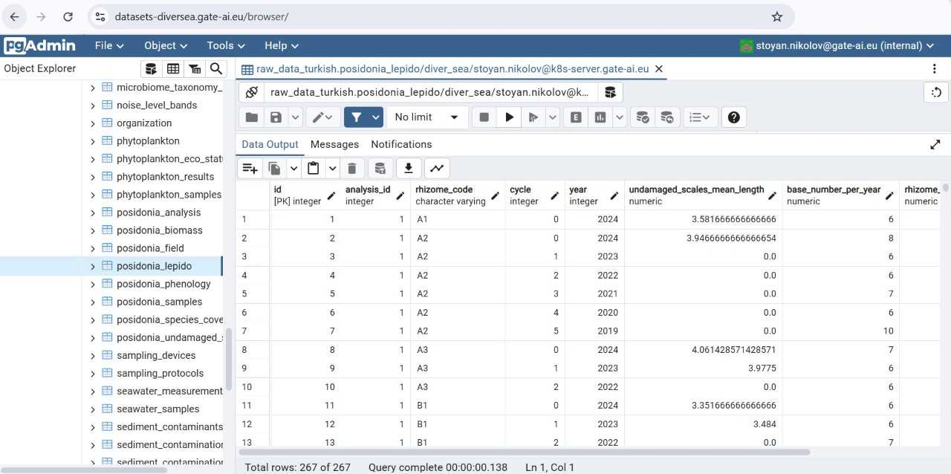
Figure 4. Posidonia Data from the Eastern Mediterranean (https://datasets-diversea.gate-ai.eu)
To access the structured data of DiverSea case studies use the links to DiverSea database repository at
https://datasets-diversea.gate-ai.eu/login?username=<cs name>&password=<cs password>
Due to security restrictions the credentials for access to the repository are currently available only to pre-set users assigned to the work package leaders or additionally authorized staff under request from the data space administrator (email: stoyan.nikolov@gate-ai.eu).
After publication, the exported datasets will be also downloadable via Copernicus and EmodNet download services at
https://emodnet.ec.europa.eu/en/emodnet-web-service-documentation#data-download-services
https://dataspace.copernicus.eu/copernicus-services

